A WEB-BASED E-WASTE DISPOSAL PLATFORM FOR CONNECTING WASTE OWNWERS WITH CERTIFIED RECYCLING FACILITIES IN NAIROBI

189803
189593

An Information Systems Project documentation submitted to the Strathmore Institute of Management and Technology in partial fulfilment of the requirements for the award of a Bachelor’s in Business Information Technology

School of Computing and Engineering Sciences

Strathmore University
Nairobi, Kenya

May 2026

Declaration
We, Silvia and Verity declare that this work has not been previously submitted and approved for the award of a bachelor’s in business information and technology from this or any other University. To the best of my/our knowledge and belief, the documentation contains no material previously published or written by another person except where a reference is made in the proposal itself.

Student’s signature:
…………………………………. [Signature]
…………………………………. [Signature]
…………………………………. [Date]

Student’s signature:
…………………………………. [Signature]
…………………………………. [Signature]
…………………………………. [Date]

Abstract
A web-based e-waste disposal platform connecting waste owners in Nairobi with certified recycling facilities will be developed. The first chapter points towards the accumulation of hazardous e-waste due to the diversion of e-waste to other disposal channels and the non-availability of easy, certified collection systems for the public. The second chapter reviews the current literature on disposal behaviours of users, existing infrastructure gaps and systems, among others, the Computers for Schools Kenya system and the WEEE Centre. The third chapter of the dissertation explains how Object Oriented Analysis and Design (OOAD) was used in conjunction with the Scrum framework to elicit requirements through interviews, observations and a literature review. The document explains the design of the system, functional and non-functional requirements, use-case diagram, class diagram, sequence diagram, ER diagrams, and database schema. Chapter five will deal with testing. Unit tests will be conducted first and afterwards integration testing will be performed along with user acceptance testing to confirm functionality and regulatory compliance. In chapter 6, the complete system will be evaluated against the original objectives and challenges will be discussed. With this system, a waste owner can schedule pickup and find verified recyclers to earn disposal credits. The administrator will authenticate recycler licenses and produce compliance reports for NEMA. This document will demonstrate how a centralized digital platform connected the waste generators to certified recyclers in Nairobi.

Table of Contents

Declaration ii
Abstract iii
Table of Contents iv
List of Abbreviations vi
List of Figures vii
CHAPTER 1: INTRODUCTION 1
1.1 Background 1
1.2 Problem Statement 2
1.3 Aim 2
1.4 Specific Objectives 2
1.5 Justification 3
1.6 Scope 3
1.7 Limitations and Delimitations 3
CHAPTER 2: LITERATURE REVIEW 4
2.1 Introduction 4
2.2 E-waste Generation Patterns and Disposal Behaviour in Nairobi 4
2.3 Challenges and Infrastructure Gaps in Existing E-Waste Disposal Efforts 5
2.4 Review of Existing Systems 6
2.4.1 Computers for Schools Kenya (CFSK) 6
2.4.2 The WEEE Centre 6
2.4.3 East African Compliant Recycling (EACR) and Stima Recyclers 7
2.5 Conceptual Framework 7
CHAPTER 3: METHODOLOGY 9
3.1 Introduction 9
3.2 Research Approach: Object-Oriented Analysis and Design (OOAD) 9
3.3 Scrum Methodology 9
3.3.1 Product Backlog 9
3.3.2 Sprint Planning 11
3.3.3 Development Environment and Tools (Sprint Backlog) 12
3.3.4 System Testing and Quality Assurance (Sprint) 12
3.4 Deliverables 12
CHAPTER 4: SYSTEM ANALYSIS AND DESIGN 13
4.1 Introduction 13
4.2 System Requirements 13
4.2.1 Functional Requirements 13
4.2.2 Non-functional requirements 15
4.3 Analysis and Design Diagrams 16
4.3.1 Use case diagram 16
4.3.2 Class diagram 16
4.3.3 Sequence diagram 17
4.3.4 Entity relationship diagram 19
4.3.5 Database Schema 20
4.3.6 Wireframes 21
References 26

List of Abbreviations
API – Application Programming Interface
CA – Communications Authority of Kenya
CFSK – Computers for Schools Kenya
EACR – East African Compliant Recycling
ICT – Information and Communication Technology
IPOS – Input, Processing, Output, and Storage
ISO – International Organization for Standardization
JWT – JSON Web Token
NEMA – National Environment Management Authority
OOAD – Object-Oriented Analysis and Design
SDG – Sustainable Development Goals
SME – Small and Medium Enterprises
SSAD – Structured Systems Analysis and Design
UAT – User Acceptance Testing
UNEP – United Nations Environment Programme
WHO – World Health Organization
WEEE – Waste Electrical and Electronic Equipment

List of Figures
Figure 1: E-Waste Framework 9
Figure 2: Scrum Framework 11

CHAPTER 1: INTRODUCTION

1.1 Background
Electronic waste (e-waste) is the world's fastest growing waste stream. It poses a critical challenge in Kenya's urban centres like Nairobi (Ngethe, 2021). Such waste contains hazardous chemicals like lead, mercury, and cadmium. These leach into soil and groundwater when unmanaged. This causes severe health risks including cancer and respiratory diseases. Most Kenyan waste owners store obsolete gadgets or dump them carelessly. A large amount of e-waste is handled through risky informal recycling methods. Planned obsolescence and poor infrastructure deepen the growing crisis. UNEP, WHO, NEMA, and academic researchers all confirm this growing crisis and its severe environmental impact.
Mismanagement of e-waste affects urban residents and pickers. They face severe toxic chemical exposure. Hazardous elements leach into local water sources. This leads to permanent public health crises. Unmanaged waste also blocks water drainage channels. This results in flooding and waterborne diseases. Structured e-waste systems could generate revenue and create employment opportunities. Researchers state that formal recycling remains inadequate. Ignoring this problem deepen environmental damage and economic losses nationwide.
Several efforts have been made to address Kenya's e-waste crisis. NEMA and the Communications Authority have developed regulatory frameworks for disposal. Extended Producer Responsibility policies attempt to hold manufacturers accountable for product disposal. However, enforcement remains weak and largely ineffective across the country. (Simiyu, Franklin , & Richard, 2023) confirm that 95% of e-waste still reaches the informal sector. (Mugami & Dr. Thomas Mose, 2025) highlight that internet service providers lack structured collection systems. Existing solutions fail to connect waste generators with certified recycling facilities. A centralized, technology-driven management system remains a critical unaddressed gap.
Despite existing regulatory frameworks and policies on managing e-waste, there is still a disconnect in practice. The persistence of the informal sector and lack of accessible, certified disposal channels for the public indicate that current strategies are insufficient. In addition, there is an urgent need to evaluate on how modern infrastructure can bridge the gap to prevent further environmental, economic and public health degradation. (Mugami & Dr. Thomas Mose, 2025) support technology-driven approaches to bridging collection gaps.

1.2 Problem Statement
The core problem is the lack of a formal, centralized infrastructure to connect e-waste generators with certified recyclers, forcing majority of hazardous waste into the informal sector. Urban residents, informal waste pickers, and small businesses are most affected. These groups lack safe, accessible channels for proper electronics disposal. Toxins contaminate shared natural resources. (Ngethe, 2021) confirms that poor disposal methods cause permanent environmental damage. (Simiyu, Franklin , & Richard, 2023) further document severe public health consequences across Kenyan communities. This crisis directly undermines SDG 3, SDG 11, and SDG 12 globally.
These SDGs are concerned with good health and well-being, sustainable cities and communities and responsible consumption and production respectively.
Kenya's waste systems were designed only for decomposable solid waste. Informal handlers use open burning and crude methods to extract materials. These practices release toxic fumes, poisoning surrounding communities and ecosystems permanently. (Simiyu, Franklin , & Richard, 2023) warn that this gap creates compounding environmental consequences. Economically, unstructured disposal wastes recoverable materials like gold and copper. Without intervention, Kenya's rapid tech consumption will intensify this public health emergency.

1.3 Aim
To develop a web-based E-waste disposal platform where waste owners can interact with certified recycling facilities, enabling automated collection scheduling, recycler verification, and incentive integration to promote formal and safe electronic waste disposal in Nairobi.

1.4 Specific Objectives
- To investigate e-waste generation patterns and disposal behaviour among urban waste owners and small businesses in Nairobi.
- To analyse existing e-waste disposal efforts to identify infrastructure and awareness gaps in Nairobi.
- To design a centralized web-based system incorporating collection scheduling, a certified recycler directory, user incentives, and a public education interface for e-waste management.
- To develop the designed e-waste management and tracking system enabling waste generators to connect directly with verified recycling facilities.
- To test the developed system to ensure functionality, usability, and compliance with e-waste disposal regulations.

1.5 Justification
This study is justified by the requirement to move from the linear model of “take-make-waste" to one that incorporates the principles of a circular economy and ensures that the economic benefits locked in the world’s e-waste are extracted effectively. By taking into account the gap revealed in studies on the increasing consumption of electronics and the relatively low rate of formal e-waste recycling, this project provides stakeholders, which include manufacturers, regulators, and informal recyclers, an essential framework that will allow them to prevent environmental pollution while ensuring the recovery of the secondary raw materials. It should be noted that the mismanagement of e-waste currently constitutes a significant threat to sustainable development, as discussed by (Madan, Gupta , & Pandey, 2026).

1.6 Scope
This project focuses on the design and development of a centralized web-based tracking system for e-waste management within the metropolitan area of Nairobi, Kenya. This entails the identification of the waste producers and their integration into the system via the Internet to NEMA-approved recyclers. This research involved the development of a functional prototype that will has a scheduling system and incentives module. However, it does not involve the logistics of transporting the waste, the chemical treatment of the waste, or the industrial e-waste produced by large manufacturing firms.

1.7 Limitations and Delimitations
The main challenge associated with this project was the lack of accessibility to data from the informal sector, especially when dealing with undocumented data. Moreover, another problem facing the project was getting participation from certified recyclers since they may have their own schedule systems. To overcome this challenge, the current research delimits itself to using only NEMA data that is publicly available and survey questions to create the directory of recyclers. In addition, the proposed system can adopt an open API design for further integration with other recyclers' databases.

CHAPTER 2: LITERATURE REVIEW

2.1 Introduction
This section reviews existing research about e-waste management globally and locally. It explores the theoretical foundations of circular economies, examines disposal behaviours among waste owners and analyses technological gaps in existing management systems. How digital interventions can connect waste owners to certified recycling facilities will be reviewed. This chapter through research, justifies a centralized waste management system. Ultimately, the review concludes by identifying research gaps that this project intends to fill.

2.2 E-waste Generation Patterns and Disposal Behaviour in Nairobi
The management of e-waste in Nairobi is characterized by a combination of waste owners and small businesses as well as the regulatory expectations. Even as the policies stress on the importance of proper disposal and recycling of e-waste, such practices are rarely observed resulting to harmful effects on the environment and health.
2.2.1 Household Disposal Behaviour
Households in Nairobi often manage their obsolete electronics in unsafely. Instead of using designated collection points, households store their outdated devices within their houses, disposing their electronics either within garbage bins or selling them to scrap dealers who recycle them using inappropriate means (Ngethe, 2021). The act of improper disposal poses significant harm to the environment as harmful chemicals such as lead and cadmium contaminate both the soil and groundwater. It causes a health hazard by inhalation, consumption, and contact exposure to toxic fumes, particles, and chemicals. Diseases associated with poor practices of disposal include respiratory ailments and cancerous tumours (Simiyu, Franklin, & Richard, 2023). Notwithstanding, NEMA guidelines stipulate that households must separate electronic wastes from household waste (NEMA, 2025).

2.2.2 Small and Medium Enterprises Disposal Behaviour
Small and Medium Enterprises (SMEs) are key contributors to e-waste in Nairobi. Since they lack an appropriate mechanism of handling their wastes, they engage in dumping them in informal ways (Mugami & Mose, 2025). It is important to note that SMEs are rarely covered under any available collection scheme and therefore dispose of their bulky waste via the informal means. They contribute to a greater extent to the creation of e-waste. Examples of common contributors include cyber cafes and retail shops.

2.2.3 Regulatory Guidelines vs Practice
According to the guidelines set by NEMA, manufacturers, importers, and distributors are held responsible for the safe disposal of their products from manufacturing right through disposal (NEMA, 2025). Contrarily, the enforcement of such laws seems inefficient and public practices contravene the rules. This creates market stalemate where the amount of e-wastes generated increases sharply yet inefficient in waste management. Consequently, toxic materials are deposited in the surrounding while valuable metals like gold, copper, and plastics are left to rot. In this respect, this project considererd the downstream supply chain process that involves transfer of e-waste from consumers to recyclers.

2.3 Challenges and Infrastructure Gaps in Existing E-Waste Disposal Efforts
Although certain policy instruments exist and there are some efforts made towards recycling, there is still an issue of insufficient disposal of electronic waste. Among the problems that can be found in Nairobi, lack of awareness, dominance of informal sectors, and weak enforcement of existing policies should be named. All three aspects combined pose a major limitation to the existing infrastructure, and a more efficient approach is required that will involve the latest technologies.

2.3.1 Awareness and Accessibility issues
A rather small number of people (20% or less) knows about certified drop-off centres for electronic products and knows how to recycle them (Madan, Gupta, & Pandey, 2026). Most of the families hire scrap dealers who are collecting items from their homes. Certified recyclers offer only passive means and cannot offer such services. As a result, lack of awareness and access to relevant information can cause hazardous effects for citizens as they will face harmful elements present in electronics.

2.3.2 Predominance of Informal Sector
Despite the presence of different measures, this problem arises because of dominance of informal waste management sectors in the community. Families tend to keep their electronic devices in storage and do not dispose of them as digital brokering platforms were not functioning (Ngethe, 2021; Simiyu, Franklin, & Richard, 2023). Nevertheless, informal collectors offer instant solutions and engage in crude recycling, which results in pollution of communities and loss of valuable materials. Copper and gold are some of the substances that get lost. As a result, this problem emerges because of the structural issues that exist in formal systems.

2.3.3 Poor Enforcement of Policy Measures
One of the approaches that Kenya introduced is extended producer responsibility, according to which companies must take charge of disposing of their products (NEMA, 2025). However, the implementation of the concept is inefficient because of unbalanced obligations and capabilities. For instance, corporate businesses have many tools and duties while households and SMEs do not have enough means to perform their actions efficiently. Therefore, there is an evident gap within the existing policy instruments.

2.4 Review of Existing Systems
Several systems for addressing the problem of e-waste in the city of Nairobi have been put in place. Such systems are governed by the National Environment Management Authority (NEMA) whose mandate is to ensure the maintenance of a register of authorized persons who handle waste (NEMA, 2025). The three major systems analysed herein are discussed in the subsequent sections below.

2.4.1 Computers for Schools Kenya (CFSK)
Computers for Schools Kenya (CFSK) operates a specialized e-waste centre that dismantles and refurbishes ICT equipment. The operation is carried out using a centralized approach, whereby the hardware is physically separated by categorizing it into groups such as motherboards, plastics, and metals to allow for future reutilization in educational settings. Even though CFSK is very efficient when it comes to prolonging the lifespan of computers, its structure and process are mainly institutional in nature and are reactionary in terms of how it works. The program does not have an online consumer interface, which makes it impossible for consumers to initiate a request or measure their contribution to the environment (CFSK, 2025).

2.4.2 The WEEE Centre
The WEEE Centre is an ISO-certified facility that specializes in professional 'urban mining' and safe disposal of information-bearing data. The approach taken in running this business involves a hub-and-spokes approach, with over 100 collection points within Nairobi city limits and a simple web interface where collection orders are made. Despite the technological prowess, this model is still passive in nature, with no live tracking dashboard provided through the web system for following up on the movement of one's waste. Additionally, the lack of any incentive/reward module reduces the chances of winning over consumers from the more appealing "instant money" services offered by the scrap traders (WEEE Centre, 2025).

2.4.3 East African Compliant Recycling (EACR) and Stima Recyclers
East African Compliant Recycling (EACR) and Stima Recyclers primarily serve as Producer Responsibility Organizations (PRO) which oversee logistics at the downstream level for electronics producers (EACR, 2025). This type of system is put in place to facilitate international environmental compliance and to issue periodic reports to the governing agencies such as NEMA. There exists a constant visibility gap in the current system, where the entire process becomes invisible after devices are handed in by consumers (Simiyu, Franklin, & Richard, 2023). In the absence of a digital brokerage application that connects homes with the certified centres, consumers find it difficult to identify authorized recyclers (Mugami & Mose, 2025).

2.5 Conceptual Framework
The proposed system aims at reducing fragmentation in e-waste management by enabling a coordinated collection ecosystem through an Input Processing Output and Storage (IPOS) framework with three primary actors: the waste owner , the Certified Recycler, and the System Administrator. At the input stage, waste owners provide waste details and location data. Certified recyclers submit their credentials and collection capacity. The system administrator validates and approves recycler licenses. During processing, the verification Module checks NEMA compliance. The Matching Engine connects users to local collection points based on proximity, and the Incentive Engine processes rewards once a successful disposal is confirmed.

At the output stage, waste owners receive a Safe Disposal Certificate. They also receive incentive notifications, which encourage proper e-waste handling. Recyclers get collection confirmations, and the administrator receives Compliance Reports and system audit data. All information is stored in a Centralized Database, which maintains synced copies of transaction history, user profiles, and disposal audit trails. Feedback loops are integrated to ensure system control, such as notifying waste owners of earned incentives and providing the administrator with real-time alerts regarding system compliance status.

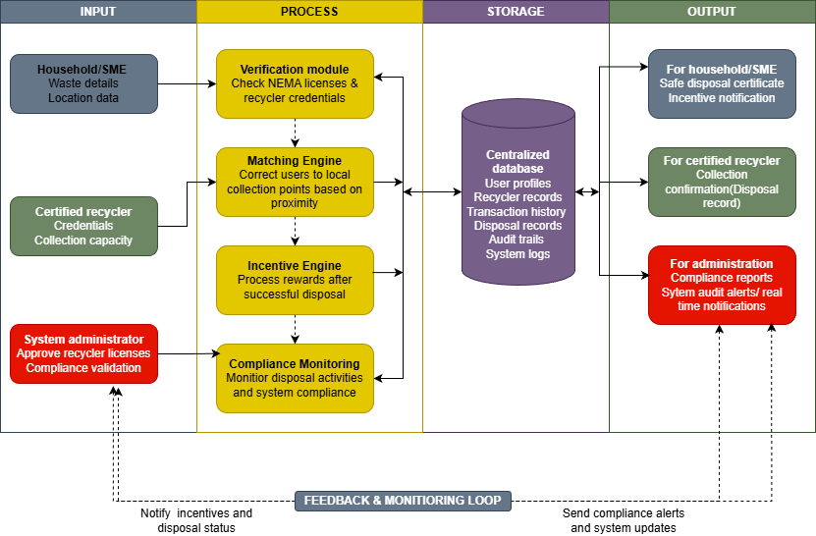
Figure 1: E-Waste Framework

CHAPTER 3: METHODOLOGY

3.1 Introduction
This section describes the research methodology used to develop the proposed centralized e-waste disposal system. This chapter explains how Object-Oriented Analysis and Design (OOAD) and Agile methodology were adopted for the accomplishment of project goals. The detailed description of the tools and techniques adopted for requirements gathering, system design, iteration, and rigorous testing is explained in the following sections. This chapter also shows that the proposed solution can realistically be implemented.

3.2 Research Approach: Object-Oriented Analysis and Design (OOAD)
The project used OOAD to guide system development. The difference between SSAD and OOAD lies in the orientation toward data flow rather than 'objects' (Dathan & Sarnath, 2025). For instance, some of the objects in our case are Recycler, Waste Item, and Pickup Request. This approach aligns with our project requirements, as the modular and scalable nature of such systems has been proven in literature. OOAD is suitable for user-centred and complex systems because it supports code reuse and easier maintenance. The gathering of functional and non-functional requirements was conducted through interviews with recyclers and waste owners, observation of existing disposal processes, and a review of related literature on e-waste disposal systems.

3.3 Scrum Methodology
Following the scrum framework, the SDLC task will be implemented through the following steps (Hron & Obwegeser, 2022):

3.3.1 Product Backlog
The project applied the Agile paradigm using the Scrum Framework. This approach supports iterative development, allowing changes to be made as requirements evolve. Examples include easier disposal processes and environmental reporting.
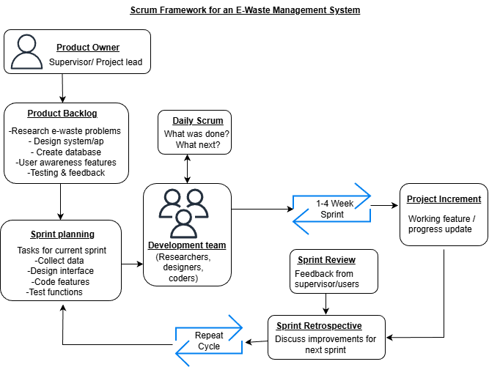
Figure 2: Scrum Framework (Hron & Obwegeser, 2022).
Under roles and backlog specification, the role of Product owner was assumed by the developer. This ensures the system meets the environmental requirements of stakeholders, such as local recycling centres. The product backlog was arranged based on the most important system requirements. High- priority features include location tracking for disposal sites and a categorization engine to distinguish between hazardous and non-hazardous electronic waste.
Regarding sprint iterations and goals, the project was executed in two-week sprints. Sprint 1 mainly focused on designing the database for storing e-waste information such as weight and toxicity level of e-waste. Sprint 2 will focus on the user interface, specifically the drop-off locator so users can view nearby collection points using GPS.

Given the nature of this project, the daily scrum will be practiced as a Self-Audit at the start of each day. The previous day’s work will be reviewed to ensure it meets the project requirements and environmental standards. This helps keep the system aligned with the project objectives. At the conclusion of each sprint, a project increment, a functional software module will be produced. For example, after sprint 2, a functional map interface will be presented for a sprint review. If the feedback indicates that users need to filter facilities by the type of waste accepted, this requirement will be added back into the product backlog for subsequent sprints.
For sprint retrospective and process optimization, the sprint review shall be applied to improve the pace of development. In case the integration of the Google Maps API for disposing off the locations takes more time than planned in sprint 2, the scope shall be altered in sprint 3. This helps the project stay on schedule while maintaining system quality.

3.3.2 Sprint Planning
The OOAD philosophy was applied practically through these phases to turn the objectives into a technical solution:
Object identification and modelling - Entities of the e-waste problem were identified. These were modelled into distinct objects such as WasteItem which contained attributes like material type, weight and toxicity level. CollectionPoint stored geo-location coordinates and operating hours. User managed disposal history and reward points. This makes the system easier to understand and organize.
Defining behaviours (models) - For each identified object, specific actions (method) were defined that align with the project goals. The WasteItem object will have a method called CalculateEnvironmentalImpact(), which computes the carbon offset based on the electronic device recycled. This keeps related functions within the same object, making the system easier to manage.
Applying principles - To ensure the system is scalable, inheritance was used. A general Waste class and specific subclasses like HazardousWaste and GeneralElectronicWaste were created. This allows different types of e-waste to be handled separately without changing the whole system.
Interface Design and Interaction - Using sequence diagrams, how these objects will interact was mapped out. For example, when a User “requests a pickup”, the system will trigger a message between the User and the CollectionPoint object to verify availability. This ensures that the functional requirements gathered are translated into logical software interactions. The analysis and design phase involved use case diagrams, class diagrams, sequence diagrams, ERDs, and wireframes to illustrate system structure and object interactions.

3.3.3 Development Environment and Tools (Sprint Backlog)
The application was built as a Web-based Application. This helps to ensure that all NEMA and recycler users have centralized access to the application while allowing the waste owner to use their mobile phones' web browsers to use the application without the need for any external applications. The React.js library was used for the frontend to build the responsive interface for e-waste registration. Its reusable components makes the interface easier to manage. It ensures the user interface remains modular and maintainable.
For the backend, Node.js was utilized to manage concurrent pick-up requests. It can support multiple users accessing the system at the same time. For example, requesting pickups or viewing the map simultaneously. The MySQL database stores all the data collected from users for Chain of Custody purposes. A relational database is necessary to maintain the integrity of metadata like toxicity levels and weight, critical for weight reporting. The coding was done in VS Code. Its integrated tools for version control and API testing support the Scrum Framework requirement for rapid, daily updates and self-audits.

3.3.4 System Testing and Quality Assurance (Sprint)
A multi-stage testing strategy was implemented to ensure system reliability. Unit Testing checked for correctness of calculations done by individual methods, such as the point calculator method. The Integration Testing followed to check the data transfer from the waste owner request module to the recycler dashboard.
User Acceptance Testing (UAT) will then follow, where actual stakeholders will test the usability of the application in Nairobi. Postman was mainly used to test the API endpoints of the application, to ensure data is transferred correctly between the frontend and backend.

3.4 Deliverables
The deliverable from this project was the creation of a working functional system that is composed of three components: the Waste Owner Portal, the Recycler Dashboard, and the Admin Analytics Portal. Each of these components would be separated for each user role and privacy. These deliverables were accompanied by design artifacts such as the OOAD Design Artifacts (Use Case, Class, and Sequence diagrams), and the Technical Report. To improve security, the project incorporated the implementation of JWT-based Authentication for providing insights into regional e-waste trends.

CHAPTER 4: SYSTEM ANALYSIS AND DESIGN

4.1 Introduction
The chapter covers the system analysis and design web-based e-waste disposal platform. It outlines the functional and non-functional requirements derived from problems identified in chapter 2. It covers the analysis and design diagrams including the use case diagram, class diagram, sequence diagram, entity relationship diagram, database schema and wireframes. These diagrams illustrate the structure, functionality, data flow and interactions within the system and demonstrates how the proposed solution addresses the problem of improper e-waste disposal.

4.2 System Requirements
The primary stakeholders are waste owners, recycler agents, and the system administrator, while the supporting actors are NEMA API, maps API and payment API. Each requirement is stated from the perspective of the person who will use the system. The following functional and non-functional requirements ensure the system meets the needs of the stakeholders while maintaining reliability, security, data integrity and efficiency.

4.2.1 Functional Requirements
The e-waste disposal platform requires a waste owner to sign up using their phone number and location details, followed by an account confirmation notification once their details are securely stored. After logging in, a waste owner inputs the type of electronic device, quantity, and condition. They then receive an estimated reward point value based on weight and device category. The system then displays nearby NEMA-certified recyclers showing distance, ratings, and operating hours. This allows the waste owner to select a preferred recycler. Once selected, the waste owner chooses a pickup date and time slot and adds any special instructions such as gate code or landmark.
The system then processes the scheduling request, stores the pickup details, and sends a confirmation via SMS and email. This confirmation contains the pickup ID, scheduled time, recycler name, and points pending verification. Upon successful disposal verified by the recycler, the system automatically adds the points to the waste owner’s account and sends a notification. Finally, the platform allows waste owners to review their total points earned, redeem points for *mobile money or other rewards*, and view their disposal history before they log out.
The recycler agent oversees the collection side of the system, beginning with facility registration that requires NEMA license verification by the system administrator before the account becomes active. Once approved, the recycler agent logs in and becomes visible to waste owners in their area. When a pickup request comes in, they receive the request details including waste items, quantity, customer location, and scheduled time. The recycler has the autonomy to accept or reject the request. Should they reject it, they must provide a reason which the system records.
Once a request is accepted, the recycler agent performs the pickup and marks it as completed, recording the actual weight of receives e-waste if different from the estimate. The system then automatically notifies the customer and awards the pending points. To maintain service visibility, recycler agents can update their facility profile including operating hours, accepted waste types, and daily capacity, which triggers an update in the system. Finally, they receive a weekly summary report showing total weight received, number of pickups completed, and points awarded to customers.
The system administrator oversees the entire platform, beginning with configuring user roles and verifying recycler registrations by checking submitted NEMA documents against the NEMA verification database. The administrative workflow involves monitoring all system activity including user registrations, pickup requests, transactions, and complaints in real time. To ensure accountability, the administrator is responsible for auditing disposal logs and storing audit logs, which serve as the backbone for regulatory compliance with NEMA requirements. When issues arise, the administrator can manually adjust a user's reward points to correct errors or award bonuses.
Furthermore, the role is highly data driven. The administrator must generate analytics reports showing total pickups completed, total e-waste collected by category, points earned across all users, and geographical waste generation patterns across Nairobi. The administrator also manages system-wide communications by broadcasting notification to all users or specific groups for maintenance alerts or educational campaigns. Finally, the administrator exports compliance reports in CSV or PDF format with transactional logs for NEMA submissions, ensuring the platform meets all regulatory reporting obligations.
To ensure the integrity of data and the security of operations, the system must enforce strict access control measures that prevent unauthorized users from performing sensitive actions. In this system, a waste owner must not be able to accept their own pickup request or change the verification status of a completed pickup. A recycler agent must not be able to change reward point calculation rules or approve their own facility registration.
In case of an emergency during pickup, both waste owners and recycler agents can trigger an SOS alert that notifies the system administrator. These constraints are enabled in system design through the implementation of role-based access control. Under these establishments, the system evaluates the user's permissions before any command is executed, ensuring that write-access is granted only to authorized roles.

4.2.2 Non-functional requirements
To ensure the system is not only functional but also robust and user-friendly, it adheres to non-functional requirements that define its operational quality. Usability is enabled through a simple mobile-responsive interface allowing a first-time waste owner to schedule a pickup within three minutes without any training. Performance is enabled through optimized database queries and lightweight API responses, ensuring the recycler map loads within two seconds even on 3G networks and the system supports up to 500 concurrent users without degradation. To safeguard user data, security is integrated via role-based access control, one-time password authentication for login, hashed passwords, and TLS encryption for all data transmitted between client and server.
The system guarantees high availability by targeting 99.5% uptime during operating hours of 6am to 10pm daily, with planned maintenance scheduled during late night hours when usage is lowest. Furthermore, reliability is maintained through automated reward point calculation with 100% accuracy and confirmation messages delivered within thirty seconds of scheduling. Maintainability is catered for in the design through modular architecture following OOAD principles and documented API endpoints, allowing developers to implement updates or fix bugs with minimal disruption to the live environment. Compliance is achieved by maintaining audit logs of all disposal transactions for three years to meet NEMA reporting requirements.

4.3 Analysis and Design Diagrams
Following the OOAD approach, the following diagrams were drawn:

4.3.1 Use case diagram
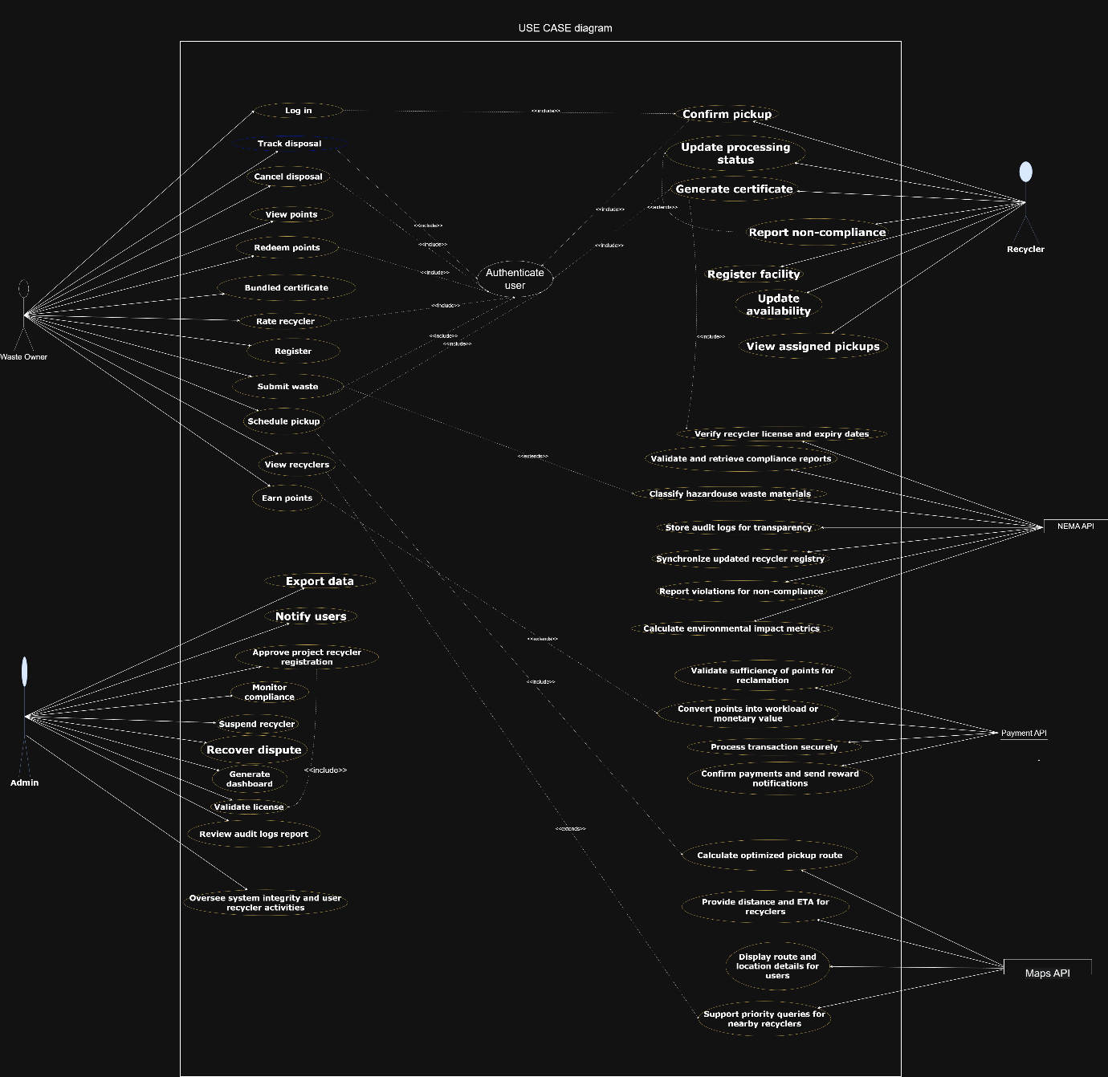

4.3.2 Class diagram

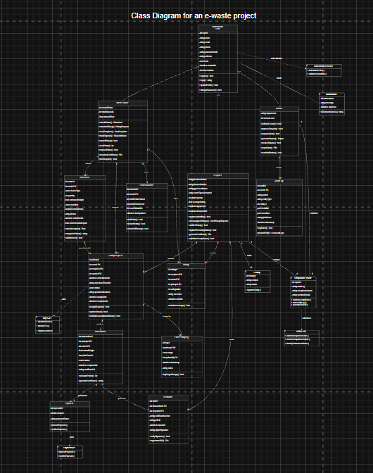

4.3.3 Sequence diagram

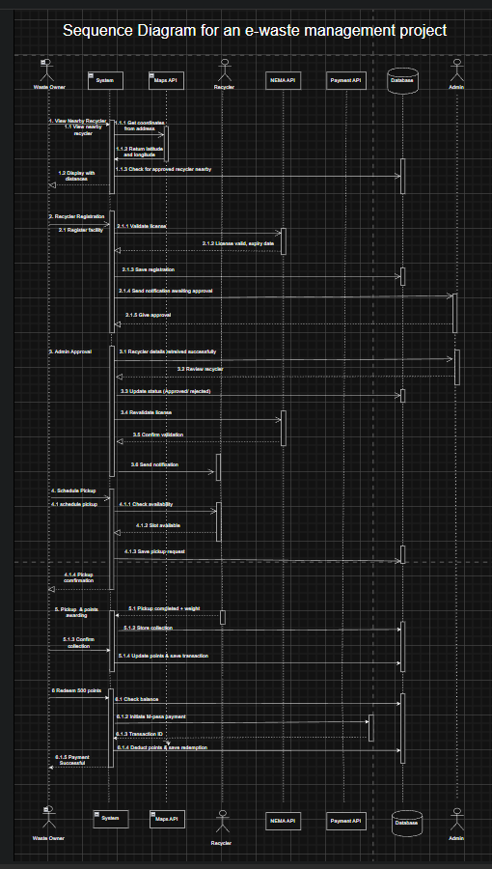

4.3.4 Entity relationship diagram
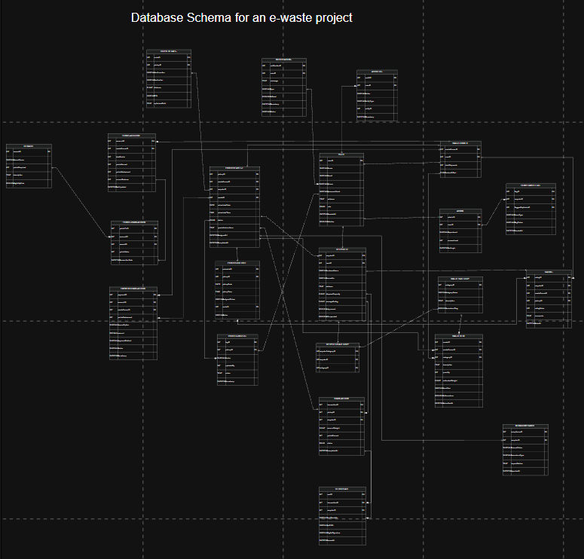

4.3.5 Database Schema


4.3.6 Wireframes
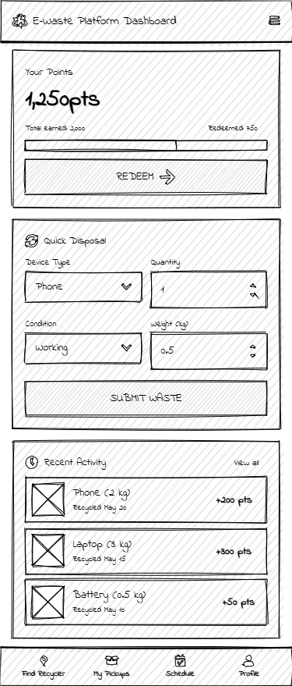

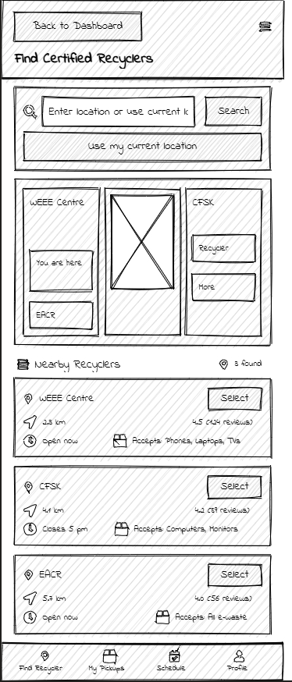
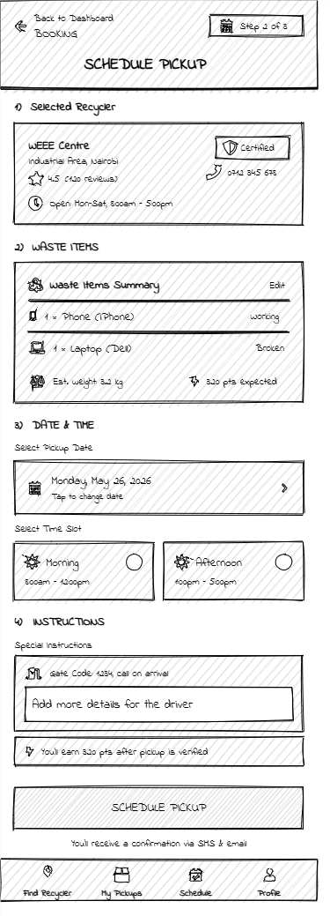
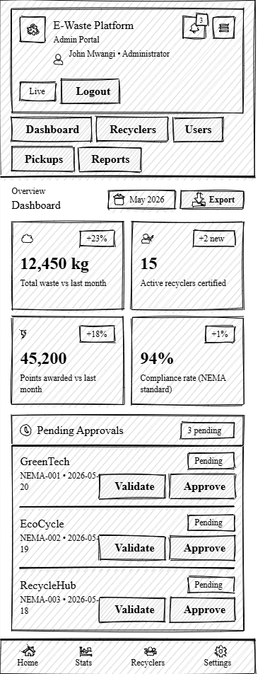
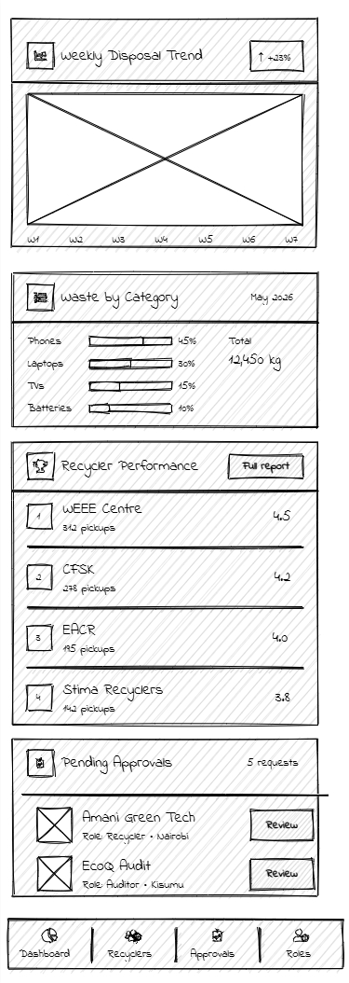

References
Dathan, B., & Sarnath, R. (2025). Object-Oriented Analysis, Design and Implementation. Springer Cham.
Hron, M., & Obwegeser, N. (2022). Why and How is Scrum being Adapted in practice: A systematic review. Journal of Systems and Software, 183.
M. S., G. N., & P. S. (2026). Challenges and opportunites in e-waste management: A global perspective. Global Transitions Proceedings, 45-58.
Mugami, O. M., & Dr. Thomas Mose, P. (2025). International Journal of Innovation, Enterprise, and Social Sciences. Electronic Waste Management Practices and Perfomance of Internet Service Providers in Kenya, 260-274.
National Environment Management Authority. (2025). National Environment Management Authority E-waste Management Guidelines. Nairobi: NEMA Kenya. From https://nema.go.ke/wp-content/uploads/2025/11/E-WASTE-GUIDELINES.pdf
Ngethe, D. (2021). Journal of Environment. Influence of electronic waste management systems in Kenya. A critical literature review., 45-60.
Simiyu, P. W., F. W., & R. R. (2023). International Journal of Multidisciplinary Research and Publications. A Critical Evaluation of the Environmental Effects of the Existing E-Waste Management Practices in Kenya, 1-3.

